# Detailed Report on Smart City Traffic & Accident Analytics

---- Sayan Das

## Note:

There were two files available—*road_traffic_sensor_data.csv* and *traffic_sensor_data.csv*. Both contained sensor information and traffic conditions. However, to generate this report, I only needed one of these datasets. I chose *road_traffic_sensor_data.csv* because the other file (*traffic_sensor_data.csv*) contained questionable data like pollution sensor, giving speed data..

## 1. Data Loading & Pre-Processing

I began by loading the provided CSV files for sensor and accident data into Python using the Pandas library. This step involved standardizing column names (converted to lower-case) for consistency.

**Python Code Snippet:**

import pandas as pd  
  
# Load CSV files  
df_sensor = pd.read_csv('road_traffic_sensor_data.csv')  
df_accident = pd.read_csv('traffic_accident_data.csv')  
  
# Standardize column names to lower-case  
df_sensor.columns = [col.lower() for col in df_sensor.columns]  
df_accident.columns = [col.lower() for col in df_accident.columns]

This allowed me to work with a consistent dataset before moving on to the quality and transformation steps.

## 2. Data Quality Checks & Cleaning

To ensure reliable analytics, I performed several data quality checks: - **Uniqueness Check:** Verified that the primary key columns (sensor_id in sensor data and accident_id in accident data) are unique. - **Missing Data Check:** Assessed the presence of null values. I opted to drop any rows with missing data for simplicity.

**Python Code Snippet:**

# Check for primary key uniqueness  
if df_sensor['sensor_id'].nunique() != len(df_sensor):  
 print("Warning: Duplicate sensor_id values found in sensor data!")  
else:  
 print("All sensor_id values are unique in sensor data.")  
  
if df_accident['accident_id'].nunique() != len(df_accident):  
 print("Warning: Duplicate accident_id values found in accident data!")  
else:  
 print("All accident_id values are unique in accident data.")  
  
# Check for missing values  
print("Missing values in sensor data:")  
print(df_sensor.isnull().sum())  
  
print("\nMissing values in accident data:")  
print(df_accident.isnull().sum())  
  
# Drop rows with missing data  
df_sensor.dropna(inplace=True)  
df_accident.dropna(inplace=True)

Additionally, I converted the date_time columns into datetime objects to facilitate further time-based transformations.

df_sensor['date_time'] = pd.to_datetime(df_sensor['date_time'])

df_accident['date_time'] = pd.to_datetime(df_accident['date_time'])

## 3. Data Transformation: Creating Dimension and Fact Tables

Following data cleaning, I transformed the raw data into a structured star schema by creating dimension tables and fact tables.

### 3.1 Creating Dimension Tables

I built the following dimension tables:

* **dim_time:**  
  I combined unique date_time values from both datasets, extracted additional attributes (year, month, day, hour, day_of_week), and created a surrogate key time_id.
* **Python Code Snippet:**
* all_times = pd.concat([df_sensor[['date_time']], df_accident[['date_time']]])  
  all_times = all_times.drop_duplicates().reset_index(drop=True)  
    
  all_times['year'] = all_times['date_time'].dt.year  
  all_times['month'] = all_times['date_time'].dt.month  
  all_times['day'] = all_times['date_time'].dt.day  
  all_times['hour'] = all_times['date_time'].dt.hour  
  all_times['day_of_week'] = all_times['date_time'].dt.dayofweek  
    
  all_times.reset_index(inplace=True)  
  all_times.rename(columns={'index': 'time_id'}, inplace=True)  
  all_times['time_id'] = all_times['time_id'] + 1  
    
  dim_time = all_times[['time_id', 'date_time', 'year', 'month', 'day', 'hour', 'day_of_week']]
* **dim_location:**  
  I consolidated unique locations from both datasets and assigned a surrogate key location_id.
* **Python Code Snippet:**
* locations_sensor = df_sensor[['location']].drop_duplicates()  
  locations_accident = df_accident[['location']].drop_duplicates()  
  all_locations = pd.concat([locations_sensor, locations_accident]).drop_duplicates().reset_index(drop=True)  
    
  all_locations.reset_index(inplace=True)  
  all_locations.rename(columns={'index': 'location_id'}, inplace=True)  
  all_locations['location_id'] = all_locations['location_id'] + 1  
    
  dim_location = all_locations[['location_id', 'location']]
* **Additional Dimensions (for Accident Data):**  
  I created separate dimensions for vehicle_type, weather_condition, and road_condition with their own surrogate keys (vehicle_id, weather_id, and road_id respectively).
* **Python Code Snippet:**
* # Vehicle Dimension  
  dim_vehicle = df_accident[['vehicle_type']].drop_duplicates().reset_index(drop=True)  
  dim_vehicle.reset_index(inplace=True)  
  dim_vehicle.rename(columns={'index': 'vehicle_id'}, inplace=True)  
  dim_vehicle['vehicle_id'] = dim_vehicle['vehicle_id'] + 1  
  dim_vehicle = dim_vehicle[['vehicle_id', 'vehicle_type']]  
    
  # Weather Dimension  
  dim_weather = df_accident[['weather_condition']].drop_duplicates().reset_index(drop=True)  
  dim_weather.reset_index(inplace=True)  
  dim_weather.rename(columns={'index': 'weather_id'}, inplace=True)  
  dim_weather['weather_id'] = dim_weather['weather_id'] + 1  
  dim_weather = dim_weather[['weather_id', 'weather_condition']]  
    
  # Road Condition Dimension  
  dim_road = df_accident[['road_condition']].drop_duplicates().reset_index(drop=True)  
  dim_road.reset_index(inplace=True)  
  dim_road.rename(columns={'index': 'road_id'}, inplace=True)  
  dim_road['road_id'] = dim_road['road_id'] + 1  
  dim_road = dim_road[['road_id', 'road_condition']]

### 3.2 Creating Fact Tables

Next, I built the fact tables by merging the cleaned data with the respective dimensions: - **fact_traffic:**  
This fact table includes the key measures from sensor data along with foreign keys linking to dim_time and dim_location.

**Python Code Snippet:** ```python # Merge with dim_time and rename to fk_time_id fact_traffic = df_sensor.merge(dim_time[[‘time_id’, ‘date_time’]], on=‘date_time’, how=‘left’) fact_traffic.rename(columns={‘time_id’: ‘fk_time_id’}, inplace=True)

# Merge with dim_location and rename to fk_location_id fact_traffic = fact_traffic.merge(dim_location, on=‘location’, how=‘left’) fact_traffic.rename(columns={‘location_id’: ‘fk_location_id’}, inplace=True)

# Select only the necessary columns fact_traffic = fact_traffic[[‘sensor_id’, ‘fk_time_id’, ‘fk_location_id’, ‘vehicle_count’, ‘average_speed’, ‘congestion_level’]] ```

* **fact_accident:**  
  This fact table holds accident-specific measures and references dimensions including dim_time, dim_location, dim_vehicle, dim_weather, and dim_road.
* **Python Code Snippet:**
* # Merge with dim_time and rename to fk_time_id  
  fact_accident = df_accident.merge(dim_time[['time_id', 'date_time']], on='date_time', how='left')  
  fact_accident.rename(columns={'time_id': 'fk_time_id'}, inplace=True)  
    
  # Merge with dim_location and rename to fk_location_id  
  fact_accident = fact_accident.merge(dim_location, on='location', how='left')  
  fact_accident.rename(columns={'location_id': 'fk_location_id'}, inplace=True)  
    
  # Merge with additional dimensions  
  fact_accident = fact_accident.merge(dim_vehicle.rename(columns={'vehicle_id': 'fk_vehicle_id'}),  
   on='vehicle_type', how='left')  
  fact_accident = fact_accident.merge(dim_weather.rename(columns={'weather_id': 'fk_weather_id'}),  
   on='weather_condition', how='left')  
  fact_accident = fact_accident.merge(dim_road.rename(columns={'road_id': 'fk_road_id'}),  
   on='road_condition', how='left')  
    
  # Select only the necessary columns  
  fact_accident = fact_accident[['accident_id', 'fk_time_id', 'fk_location_id', 'fk_vehicle_id', 'fk_weather_id', 'fk_road_id','accident_severity', 'number_of_vehicles', 'casualties','traffic_density']]

## 4. Loading Transformed Data to MySQL

After the ETL process, I loaded the dimension and fact tables into a MySQL database using SQLAlchemy. I configured the connection parameters and used the to_sql() method with if_exists='replace' to update the tables.

**Python Code Snippet:**

from sqlalchemy import create_engine  
  
# MySQL connection parameters  
username = 'root'  
password = '12345'  
host = 'localhost'  
port = '3306'  
database = 'case6'  
  
# Create the SQLAlchemy engine  
engine = create_engine(f'mysql+pymysql://{username}:{password}@{host}:{port}/{database}')  
  
# Load tables into MySQL  
dim_time.to_sql('dim_time', con=engine, index=False, if_exists='replace')  
dim_location.to_sql('dim_location', con=engine, index=False, if_exists='replace')  
dim_vehicle.to_sql('dim_vehicle', con=engine, index=False, if_exists='replace')  
dim_weather.to_sql('dim_weather', con=engine, index=False, if_exists='replace')  
dim_road.to_sql('dim_road', con=engine, index=False, if_exists='replace')  
fact_traffic.to_sql('fact_traffic', con=engine, index=False, if_exists='replace')  
fact_accident.to_sql('fact_accident', con=engine, index=False, if_exists='replace')  
  
print("\nAll tables have been loaded successfully into MySQL!")

## 5. SQL Queries for Insights

Schema:

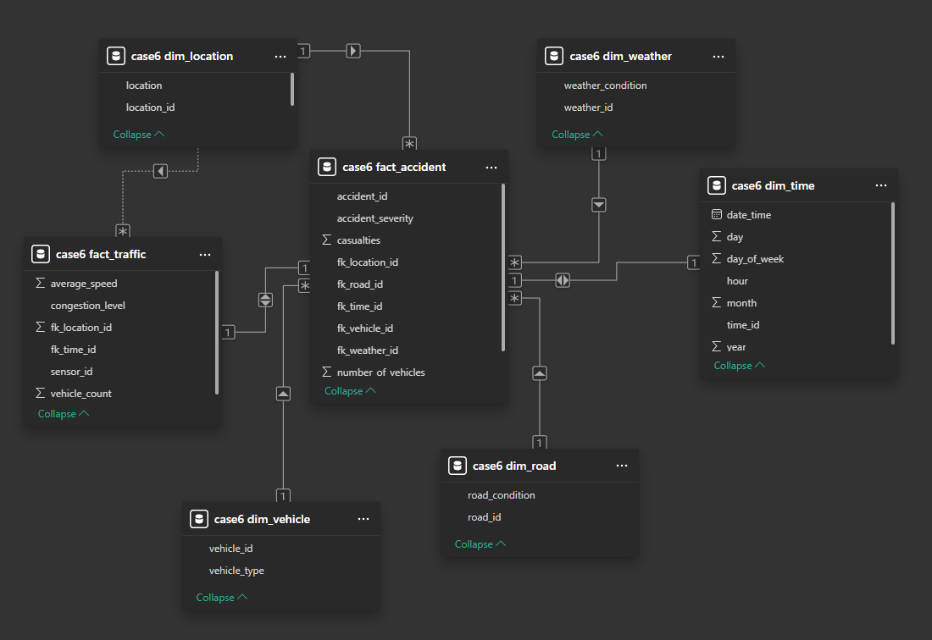

USE case6;  
  
-- 1. Show traffic congestion by location and time  
SELECT  
 dl.location,  
 dt.date_time,  
 ft.congestion_level,  
 ft.vehicle_count,  
 ft.average_speed  
FROM fact_traffic AS ft  
JOIN dim_time AS dt   
 ON ft.fk_time_id = dt.time_id  
JOIN dim_location AS dl  
 ON ft.fk_location_id = dl.location_id  
ORDER BY dt.date_time;

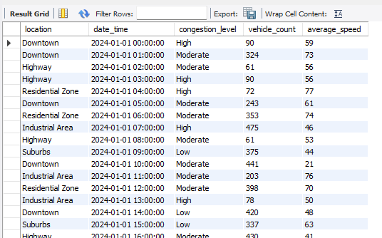

-- 2. Show top 10 accident-prone areas  
SELECT  
 dl.location,  
 COUNT(*) AS total_accidents  
FROM fact_accident AS fa  
JOIN dim_location AS dl  
 ON fa.fk_location_id = dl.location_id  
GROUP BY dl.location  
ORDER BY total_accidents DESC  
LIMIT 10;

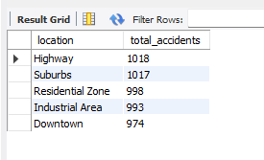  
  
-- Example: Top locations with the highest count of 'Fatal' accidents  
SELECT   
 dl.location,  
 COUNT(*) AS fatal_accidents  
FROM fact_accident AS fa  
JOIN dim_location AS dl  
 ON fa.fk_location_id = dl.location_id  
WHERE fa.accident_severity = 'Fatal'  
GROUP BY dl.location  
ORDER BY fatal_accidents DESC  
LIMIT 10;

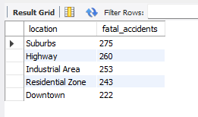  
  
-- 3. Peak hour analysis for accidents  
SELECT  
 dt.hour,  
 COUNT(*) AS total_accidents  
FROM fact_accident AS fa  
JOIN dim_time AS dt  
 ON fa.fk_time_id = dt.time_id  
GROUP BY dt.hour  
ORDER BY total_accidents DESC;  
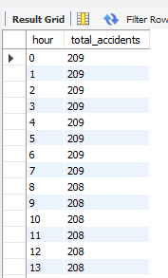  
-- 4. Peak Hour for Traffic Volume  
SELECT  
 dt.hour,  
 SUM(ft.vehicle_count) AS total_vehicles  
FROM fact_traffic AS ft  
JOIN dim_time AS dt  
 ON ft.fk_time_id = dt.time_id  
GROUP BY dt.hour  
ORDER BY total_vehicles DESC;  
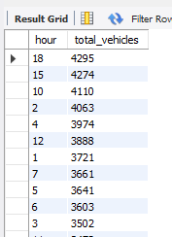  
-- 5. Average speed by hour  
SELECT  
 dt.hour,  
 AVG(ft.average_speed) AS avg_speed  
FROM fact_traffic AS ft  
JOIN dim_time AS dt  
 ON ft.fk_time_id = dt.time_id  
GROUP BY dt.hour  
ORDER BY avg_speed;

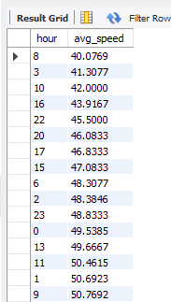

-- 4. Peak hour analysis for traffic volume

SELECT

dt.hour,

SUM(ft.vehicle_count) AS total_vehicles

FROM fact_traffic AS ft

JOIN dim_time AS dt

ON ft.fk_time_id = dt.time_id

GROUP BY dt.hour

ORDER BY total_vehicles DESC;

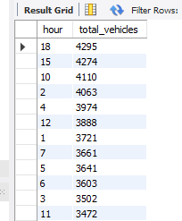

## 6. PowerBI Report

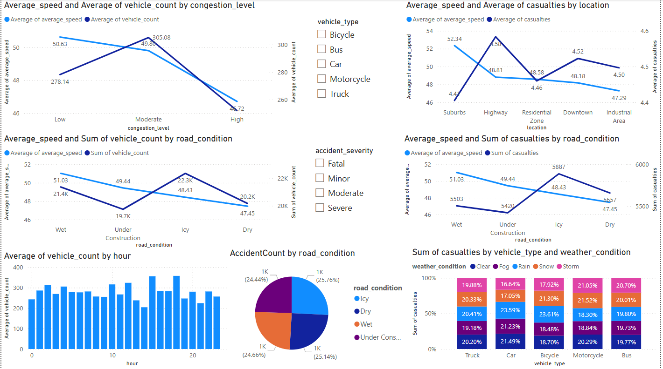

# Conclusion

* **Focus on High‐Congestion Zones/Times:** Implement dynamic traffic signals, ramp metering, or congestion pricing in the hours and locations where congestion is severe and speed is low.
* **Improve Road Safety in Hazardous Conditions:**
  + **Icy or Wet Roads:** Deploy salting trucks, improved drainage, or better signage.
  + **Under Construction Areas:** Enhance signage, set lower speed limits, and ensure construction zones are well-lit.
* **Target Vehicle-Specific Interventions:**
  + **Buses**: Possibly large casualties due to high passenger count—enforce rigorous driver training and vehicle maintenance.
  + **Motorcycles**: High vulnerability in bad weather—promote protective gear, stricter licensing.